**Resource Guide**

**November 14, 2024**

**Alamo Area Clean Cities Stakeholder Meeting**

***With Winn-Marion and GenCell***

*Presented By:*

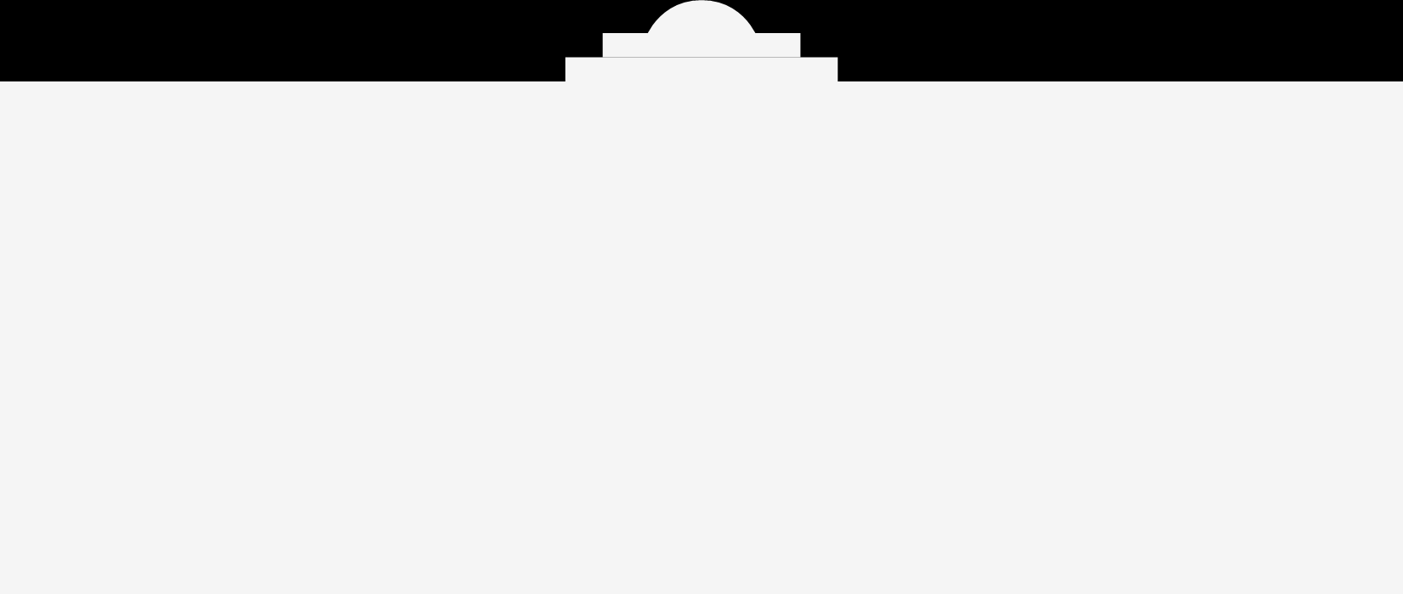

**Contact Information**

**Shawn Wilson Alex Saucedo**

EV Charging Stations Director of Sales & Business

Winn-Marion Companies Development

[ShawnWilson@winn-marion.com](mailto:ShawnWilson@winn-marion.com) GenCell Energy

(512) 804-9057 [Alex.saucedo@gencellenergy.com](mailto:Alex.saucedo@gencellenergy.com)

**Lyle Hufstetler Ella Nash**

Natural Resources Project Administrator Natural Resources Outreach

Alamo Area Council of Governments Specialist

[lhufstetler@aacog.gov](mailto:lhufstetler@aacog.gov) Alamo Area Clean Cities

(210) 376-9901 [enash@aacog.gov](mailto:enash@aacog.gov)

(210) 956-0672



# **Resources**

**Meeting Materials:**

* [Recording](https://www.youtube.com/watch?v=D0-i9mLcUbo)
* [AACCC Slide Deck](https://files.constantcontact.com/3f0fbfd7701/1df142a1-882d-4e61-a5c8-2b7ca7207aee.pdf?rdr=true)

**GenCell**

* [GenCell Website](https://www.gencellenergy.com/)
* [EVOX Overview](https://files.constantcontact.com/3f0fbfd7701/2747bd46-e0f5-4297-97bc-0cfad7d8943c.pdf?rdr=true)
* [EVOX Product Video](https://www.youtube.com/watch?v=IZa310TTXbw)

**Winn-Marion Companies**

* [Winn-Marion Charging Solutions](https://issuu.com/winn-marion/docs/2023_ev_charging_brochure)
* [Winn-Marion Website](https://winn-marion.com/services/ev-charging/)